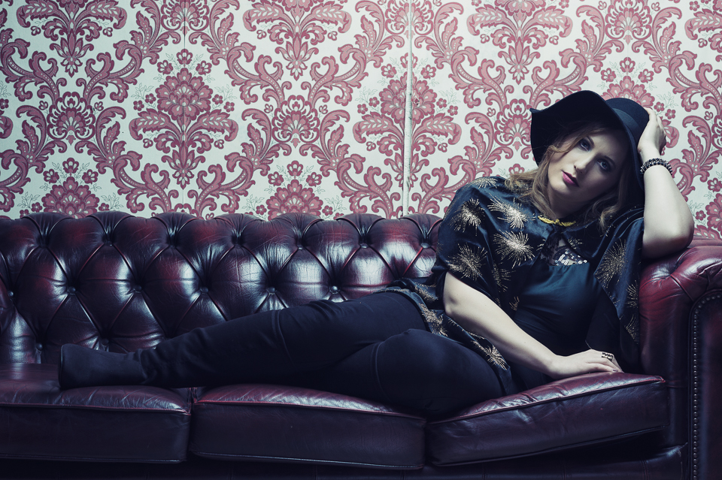
_________________________________________________________
Artist: Caroline Gilmour
Label: Unsigned
More info: www.carolinegilmour.com and http://www.theeves.co.uk

Caroline Gilmour is a UK No.1 selling singer and songwriter, podcast presenter and creative.
A coal miner's daughter who studied music at High School, she started out singing in local bars and working men’s clubs across Scotland. Over time Caroline started writing her own material. After joining her first band as a lead singer in her early 20s, she decided to go it alone to forge a career as a solo artist in 2008.
Her first official album ‘Take A Look’ was independently released in 2011, seeing her team up with Glasgow based writer and producer Jamie Duffin. Jamie's father Graeme Duffin (Wet Wet Wet) also had a hand in the final mastering process at The Foundry Music Lab in Motherwell.
In 2012, Caroline worked with Jamie again and released the 4-track EP ‘What Georgina Said’. This EP propelled her onto the Scottish music scene, garnering a number of favourable reviews and interviews, with radio play on BBC Radio Scotland, Bauer Media’s Scottish In:Demand Uncut show, Amazing Radio and reviews in The Scottish Sun, The Daily Record, Diva Magazine and i.on Magazine.
​A dance remix of her track 'Space' from 'Take A Look' was released in 2013. Produced by DJ Craig Wilson, it received airplay across various dance music channels as well as Amazing Radio.
In 2014 Caroline worked with Edinburgh-based music producer Al James to release the single Paper Planes. The B-Side 'Together In Electric Dreams', a cover of the hit 80s electronic track written by Philip Oaky and Giorgio Moroder, received radio play from BBC Radio Scotland.
​Her last EP 'Electric Waterfalls' was independently released in 2016 and went straight in at No.1 in the UK Official Vinyl Singles Chart and No.2 in the Physical Singles Chart.
Caroline has opened for artists such as Charlotte Church, Horse, Kim Churchill, Paper Aeroplanes, Dean Owens, Eleanor McEvoy, Tom Baxter, Jon Gomm and Sam Brookes.
Performance highlights include Celtic Connections, St Andrew's Day Celebrations, The Edinburgh Fringe, MTV Staying Alive Foundation, The Cavern Club in Liverpool and the Monto Water Rats in London.
She is well known for her International house concert performances covering Australia, Denmark, Germany and Spain, and has made several TV appearances on STV's The Fountainbridge Show and The Late Show.
​Caroline is now also one half of pop music duo The Eves with Marissa Keltie. The duo have received an enthusiastic media reception to their first two singles 'Tides' and 'Christmas In Summertime', with a new single due out early 2019. They have just signed their first worldwide management deal and are opening for The Shires on 25th May 2019 at The Kelvingrove Bandstand in Glasgow.
​Caroline co-hosts The CAKE Show - an Internet radio podcast with Event Announcer and Stadium DJ Keith Easton. The show features new music, classic pop songs and entertainment industry chat.
​Her other creative pursuits are photography and abstract painting, and she has recently been appointed Patron of 6VT Youth Café - an Edinburgh-based charity specialising in providing support for young people from all walks of life.

More information

If you would like more information about Caroline or would like to contact her about interview opportunities / review copies, contact David Rogers at: dcr@hanoicreative.com +44 7595 893 931

